Ideation FYP:

**Hiding ducks**

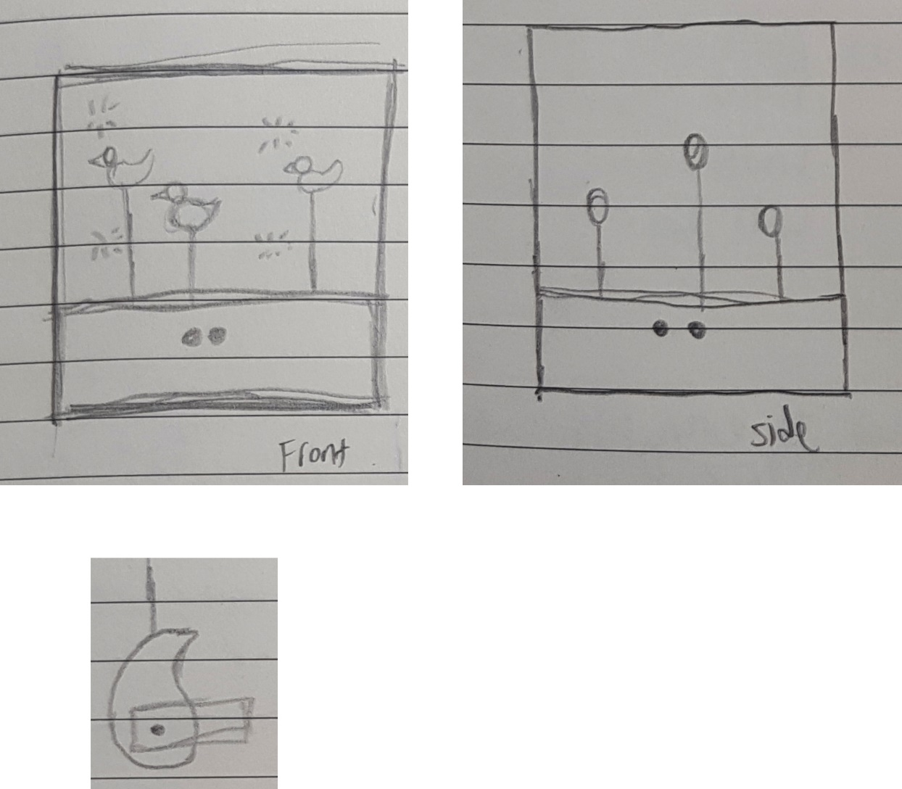

There will be a box with ducks inside which will be moving. Sensors will be attached to the box and if they sense anyone approaching from within a certain radius, the ducks will hide. This is achieved by making use of a certain shape (shown on the bottom left) to translate circular motion to vertical motion. Possible sensors to use for people sensing is an ultrasonic sensor or a RCWL-0516 Microwave proximity sensor.

The idea behind this is COVID19. As we have seen in the news, without people, nature has been returning to urban areas. Thus this is a replica of humans disappearing and animals returning.

**Theremin concept**

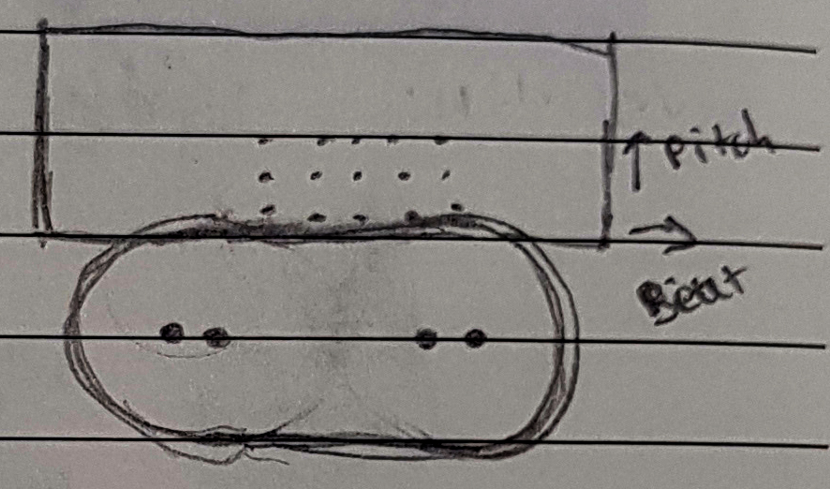

Using the concept of a theremin where distance and direction of the hand from the antenna is used to measure the pitch and beat of the instrument, I though of using 2 sensors to measure the distance from the display and play the appropriate pitch and beat. An alternative to using distance sensors would be using a camera and having certain poses correspond to some fixed beats/pitches. The beat and pitch would then be displayed on the LED matrix board on the back.

**Interactive water display**

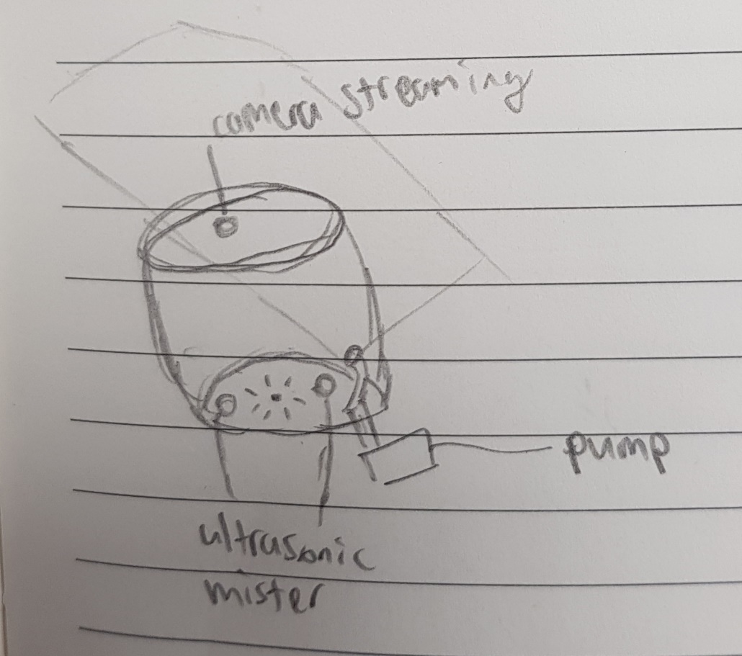

Through an application online, users will be able to see and interact with this water display. They will be able to see it through a camera the will be streaming from the top and control various actuators through the internet. Various actuators currently thought off are, LED lights, mini water pumps and ultrasonic misters. These 3 would already allow for a wide range of different displays in the water.

I understand that due to the water element, this might be a bit messy.

**Real time weather display**

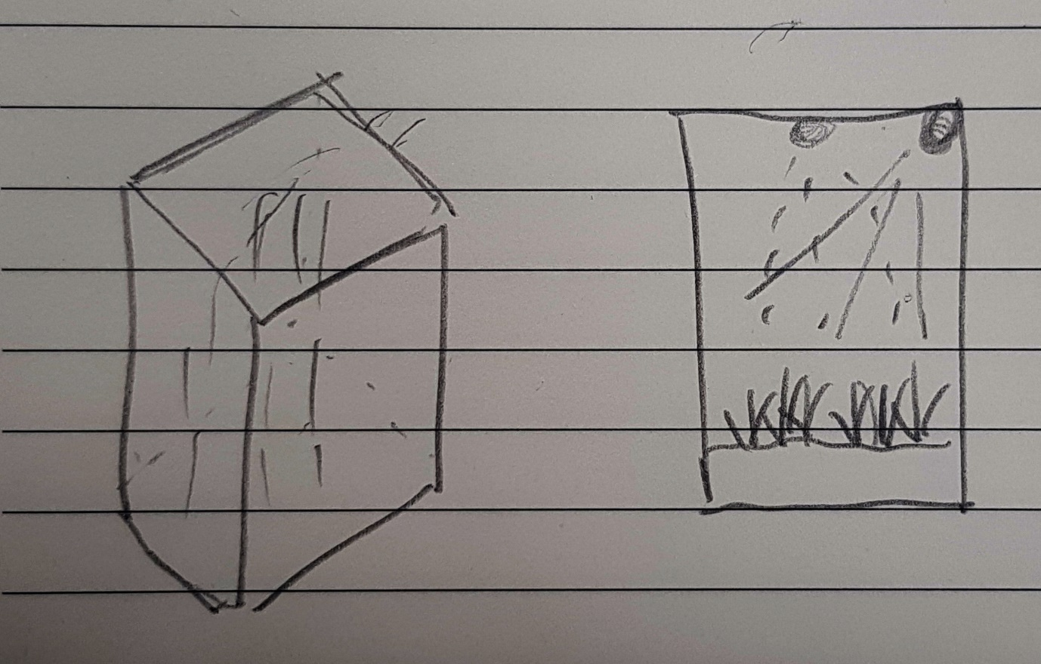

Using connections to the internet, a semi enclosed tank will replicate the weather we are having in real time. Light for the sun, water sprinkler/pump for rain. As Singapore has only 2 kinds of weather, perhaps temperature can be taken into account as well using a Peltier device.

An alternative would be to have the user control the kind of weather inside the tank via buttons or a webapp.

**Magnetic Chaos**

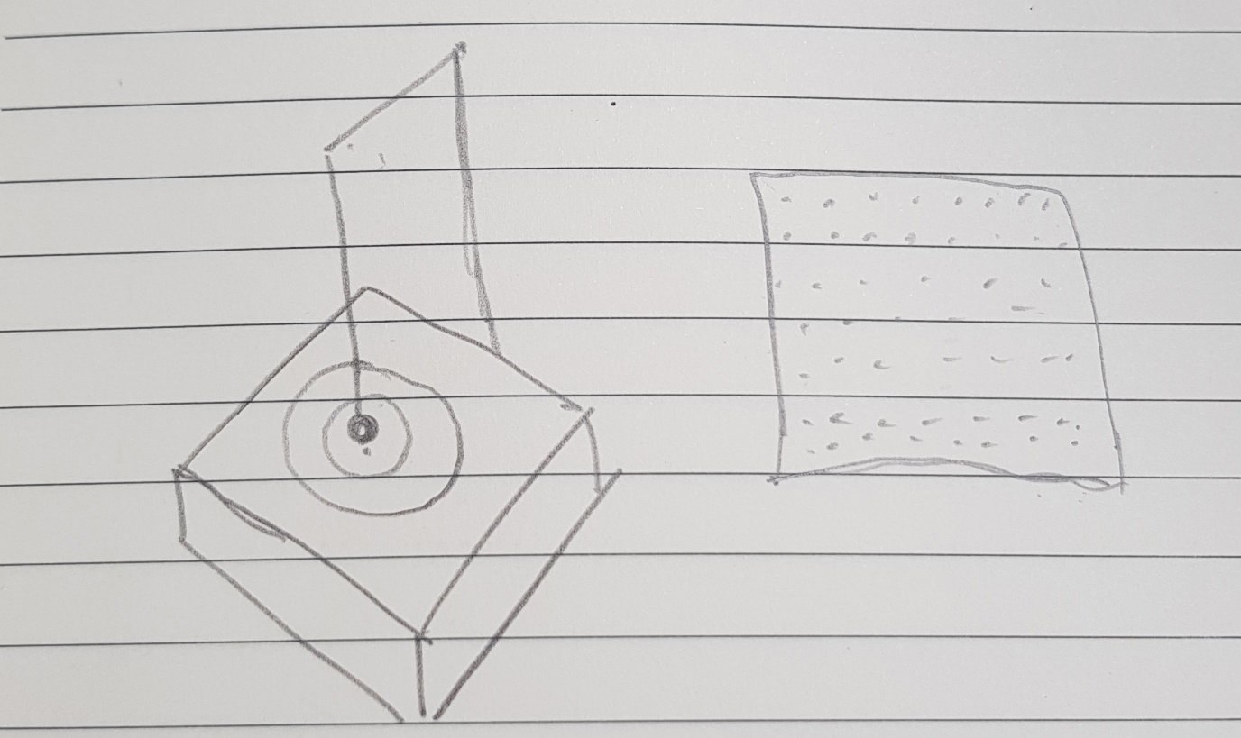

A magnet will be suspended above the board which is an LED matrix. Beneath the board are hall effect sensors able to sense the magnetic field created by the magnet. Upon a strong magnetic field, IE: The magnet is above the sensor, the corresponding led will light up. This will create a visualization of the chaos theory in action. The LEDs will also be replicated in the digital world by having a screen the represents the LEDs lighting up in real time.